Clothes–Accessories

PINS
Small pins, for hat, lapel or…. available from Squadron @ $.80 each, postage included or $15/50 from Tucker (405) 414-8935

SNAP “PINS”
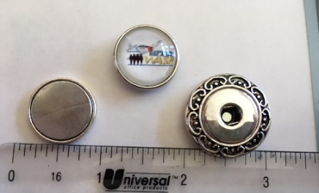
Squadron snap, with magnetic holder; use snap by itself
Or use the holder on most any fabric

Available from Snappy Chicks @ $5 for snap and $15 for holder; (620) 402-2984

JACKETS
(Left to right: rain with hood, fleece, all weather with light fleece lining)

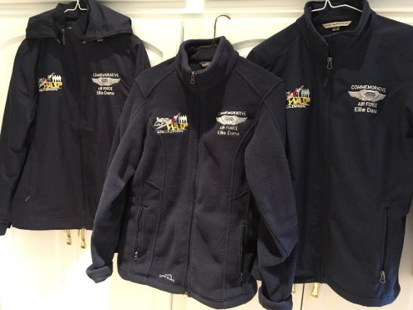

SHIRTS
(Left to right: Cotton Twill, short sleeve tech fabric, long sleeve tech fabric)
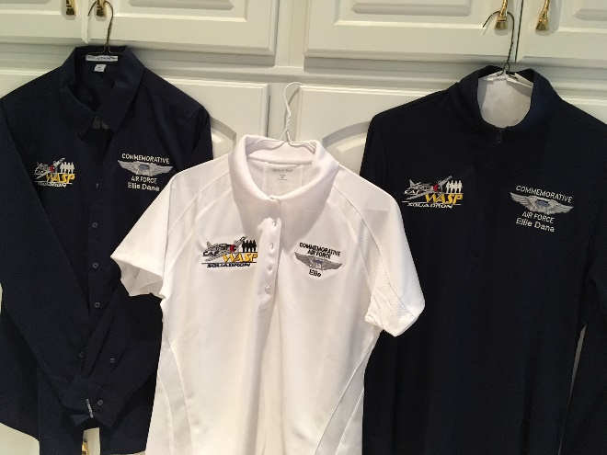

Available in these and many other styles/options; women and men cut and sizes; for smaller sizes ask for the logos to be reduced slightly.

Caps are also available

allstarwarbirds@aol.com
(763) 631-1502

